**Assignment-3**

|  |  |
| --- | --- |
| Student Name | Ms. M. Santhosam |
| Student Roll Number | 6113191031086 |
| Maximum Marks |  |

**Question-1:**

Create a Bucket in IBM object storage.

* First, creates a Service or Resource instance.
* IBM Cloud Object Storage is a multi-tenant system, and all instances of Object Storage share physical infrastructure.
* You will be automatically redirected to the service instance upon its creation. Your Object Storage instances are listed under **Storage** in the resource list.

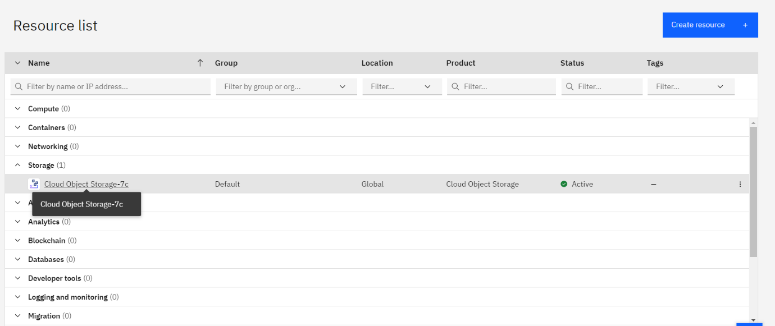

* To **Create a bucket**, start by choosing a unique name(green).
* All buckets in all regions across the globe share a single namespace.
* When you name buckets or objects, be sure to avoid the use of Personally Identifiable Information (PII). PII is information that can identify any user (natural person) by name, location, or any other means.

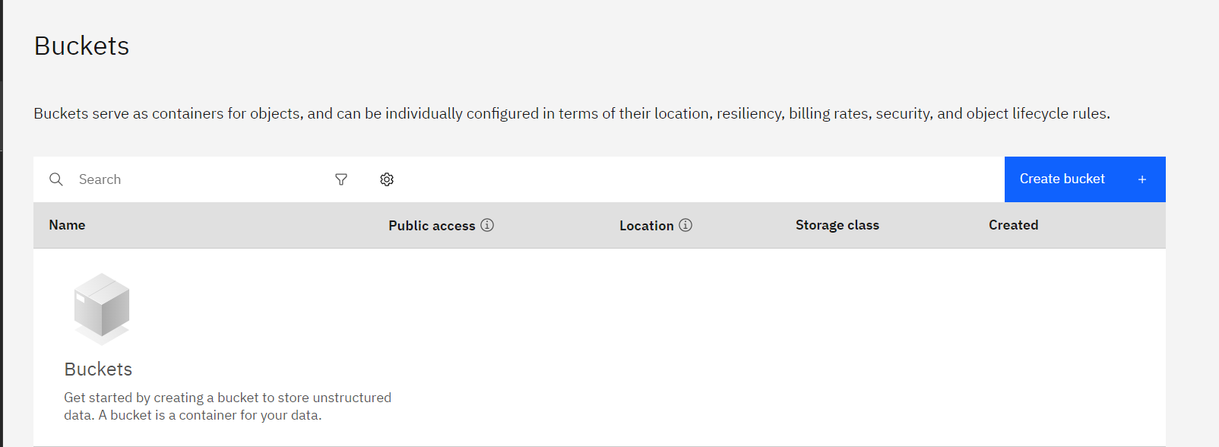

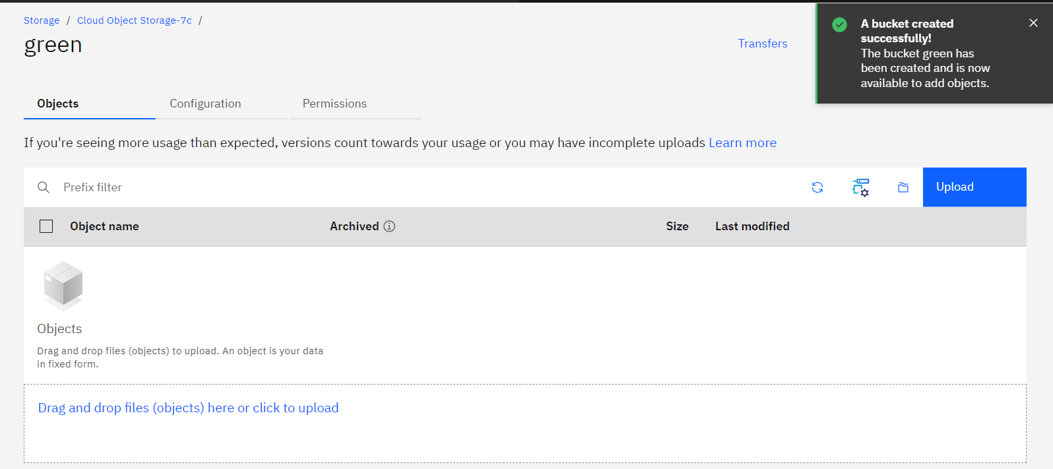

**Question-2:**

Upload an 5 images to ibm object storage and make it public.

* Click upload option in the top right corner or choose drag and drop files option in your bucket(green).
* Upload 5 images with publicly accessible as shown below,

